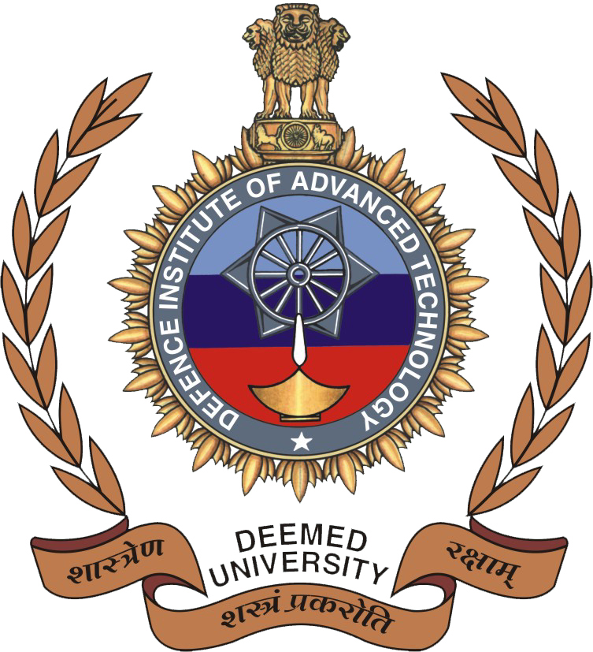 Defence Institute of Advanced Technology
(Deemed to be University) under section 3 of UGC Act 1956),
Girinagar, Pune-411025

APPLICATION FORM FOR
Institute Post-Doctoral Fellowship at DIAT
Department / School ………………………………………………………
(To get the name of the Departments / Schools visit: http://www.diat.ac.in)
- Name :

PHOTOGRAPH

Affix Recent Passport Size Photo
Date of Birth (DD/MM/YYYY): Age:

Address for Communication: Permanent Address:

Pin Code : Pin Code:
Phone No. : Phone No:
Mobile No. :
Email ID :

- Details of University/Institution Studied (Bachelor's level and above)
Sl.  No. | Degree | Discipline | University/College | Year | Average Percentage/CGPA | Class/ Grade/ Rank (if any)

- Whether any degree was obtained through' Correspondence course/distance education mode
(Tick the relevant) Yes No (If yes, give the details below)
……………………………………………………………………………………………………………

- Professional Experience (Teaching/ Research/ Industrial) if any:
Name of Organization | Designation | Period |  | Nature of Work
Name of Organization | Designation | From | To | Nature of Work
- Publication details (give numbers here and attach list of publications with Title/Year of Publications etc. in a separate sheet):
 | International | National
Journal Papers
Conference Publications

- Personal Information:
  - Father's/ : Spouse’s Name
  - Father's :

(h) Whether the : applicant is employed?

Yes No

/Spouse’s occupation
(If yes, the application should be submitted through proper channel or NOC from the employer has to be submitted at the time of interview)

  - Place of Birth: (i ) Gender : Male Female

  - Mother tongue: (j) Category : Gen
SC
EWS
ST
OBC- NCL

  - Nationality :
(If you belong to PIO/OCI/Foreign National category, kindly mention it above along with your Nationality & enclose valid passport copy for the same)

  - Annual Income :

  - Marital Status : Married Unmarried
(If you belong to any one of the above categories other than General, then enclose valid certificate for the same)

(k) Whether Physically: YES NO Challenged
(If yes, enclose the relevant copy of the medical certificate briefly describing the nature of disability)

………………………………………………………………………………………………………………………………………
DECLARATION
I hereby declare that I have carefully read the instruction and particulars supplied to me and that the entries made in the application form are correct to the best of my knowledge and belief. I understand that association (active or passive) with any unlawful organization is forbidden. If selected for admission, I promise to abide by the rules and discipline of the Institute.
I note that the decision of the Institute is final in regard to selection and assignment to a particular department and field of study. The Institute shall have the right to expel me from the Institute at any time after my admission, provided it is satisfied that I was admitted on false particulars furnished by me or my antecedents prove that my continuance in the Institute is not desirable. I agree that I shall abide by the decision of the Institute, which shall be final.
I hereby further declare that; I have not completed three years since completion of my Ph.D.

Place :
Date : Signature of the Applicant
………………………………………………………………………………………………………………
Check List:
- The filled up application form should have the following enclosures:
  - A two page write‐up on the intended Research work at DIAT
  - At least two letters of recommendations/reference from peers regarding the research capabilities and other attributes.
  - No objection certificate / Relief certificate from the present employer (if currently employed).
  - Self-attested Photo copies of the UG/PG/Ph.D. Thesis submission / Provisional / Degree certificates & Experience certificate (if any) and Birth/Matriculation certificate.
  - Caste certificate [for OBC-NCL (issued in the current financial year)/SC/ST] / Income & Assets certificate issued in the current financial year (for EWS) / Disability certificate (for PwD) / [PIO/OCI/Foreign National Passport copy - if applicable]
  - Scanned copy of two best journal papers.
  - List of Publications with Title/Year of Publication etc.
- Separate application should be sent, if any one wants to apply to more than one department.

INSTITUTE POST DOCTORAL FELLOW

AT DIAT (DU), Girinagar, PUNE

NO OBJECTION CERTIFICATE FROM THE EMPLOYER
(To be submitted along with Application)

The application of …..…………..………………………………………. working as
..……….……………………………………………… in …….…………………………………..…………

……………..………………………………………………… since ………………..……….., is herewith recommended and forwarded for Institute Post-Doctoral Fellowship at DIAT, Pune in the Department / School of …………………………………………………………

This organization does not have any objection for accepting PDF at DIAT, Pune, if selected, the applicant will be deputed/granted leave.

- Till the completion of his/her research programme, the applicant will not ordinarily be transferred to another unit or place which may impede his/her work under the scheme. If such a transfer is necessary, DIAT, Pune will be informed within a month of such transfer. We understand that continuing of PDF will depend on DIAT decision in this regard, taking into account all relevant factors.

Date : Signature of the Officer :

Seal of the Organization Name and Designation :

Postal address of the Organization :

E-Mail:

Ph. No:

